# Pets

You need to add 20 things to this document. (Make sure to number them just as I did in the example.) It may be helpful to copy and paste this list and then fill it in as you go along. All image names must start with your location, e.g yellowstone_sunset.jpg unless you are using a link from the internet.

## Sage

1. 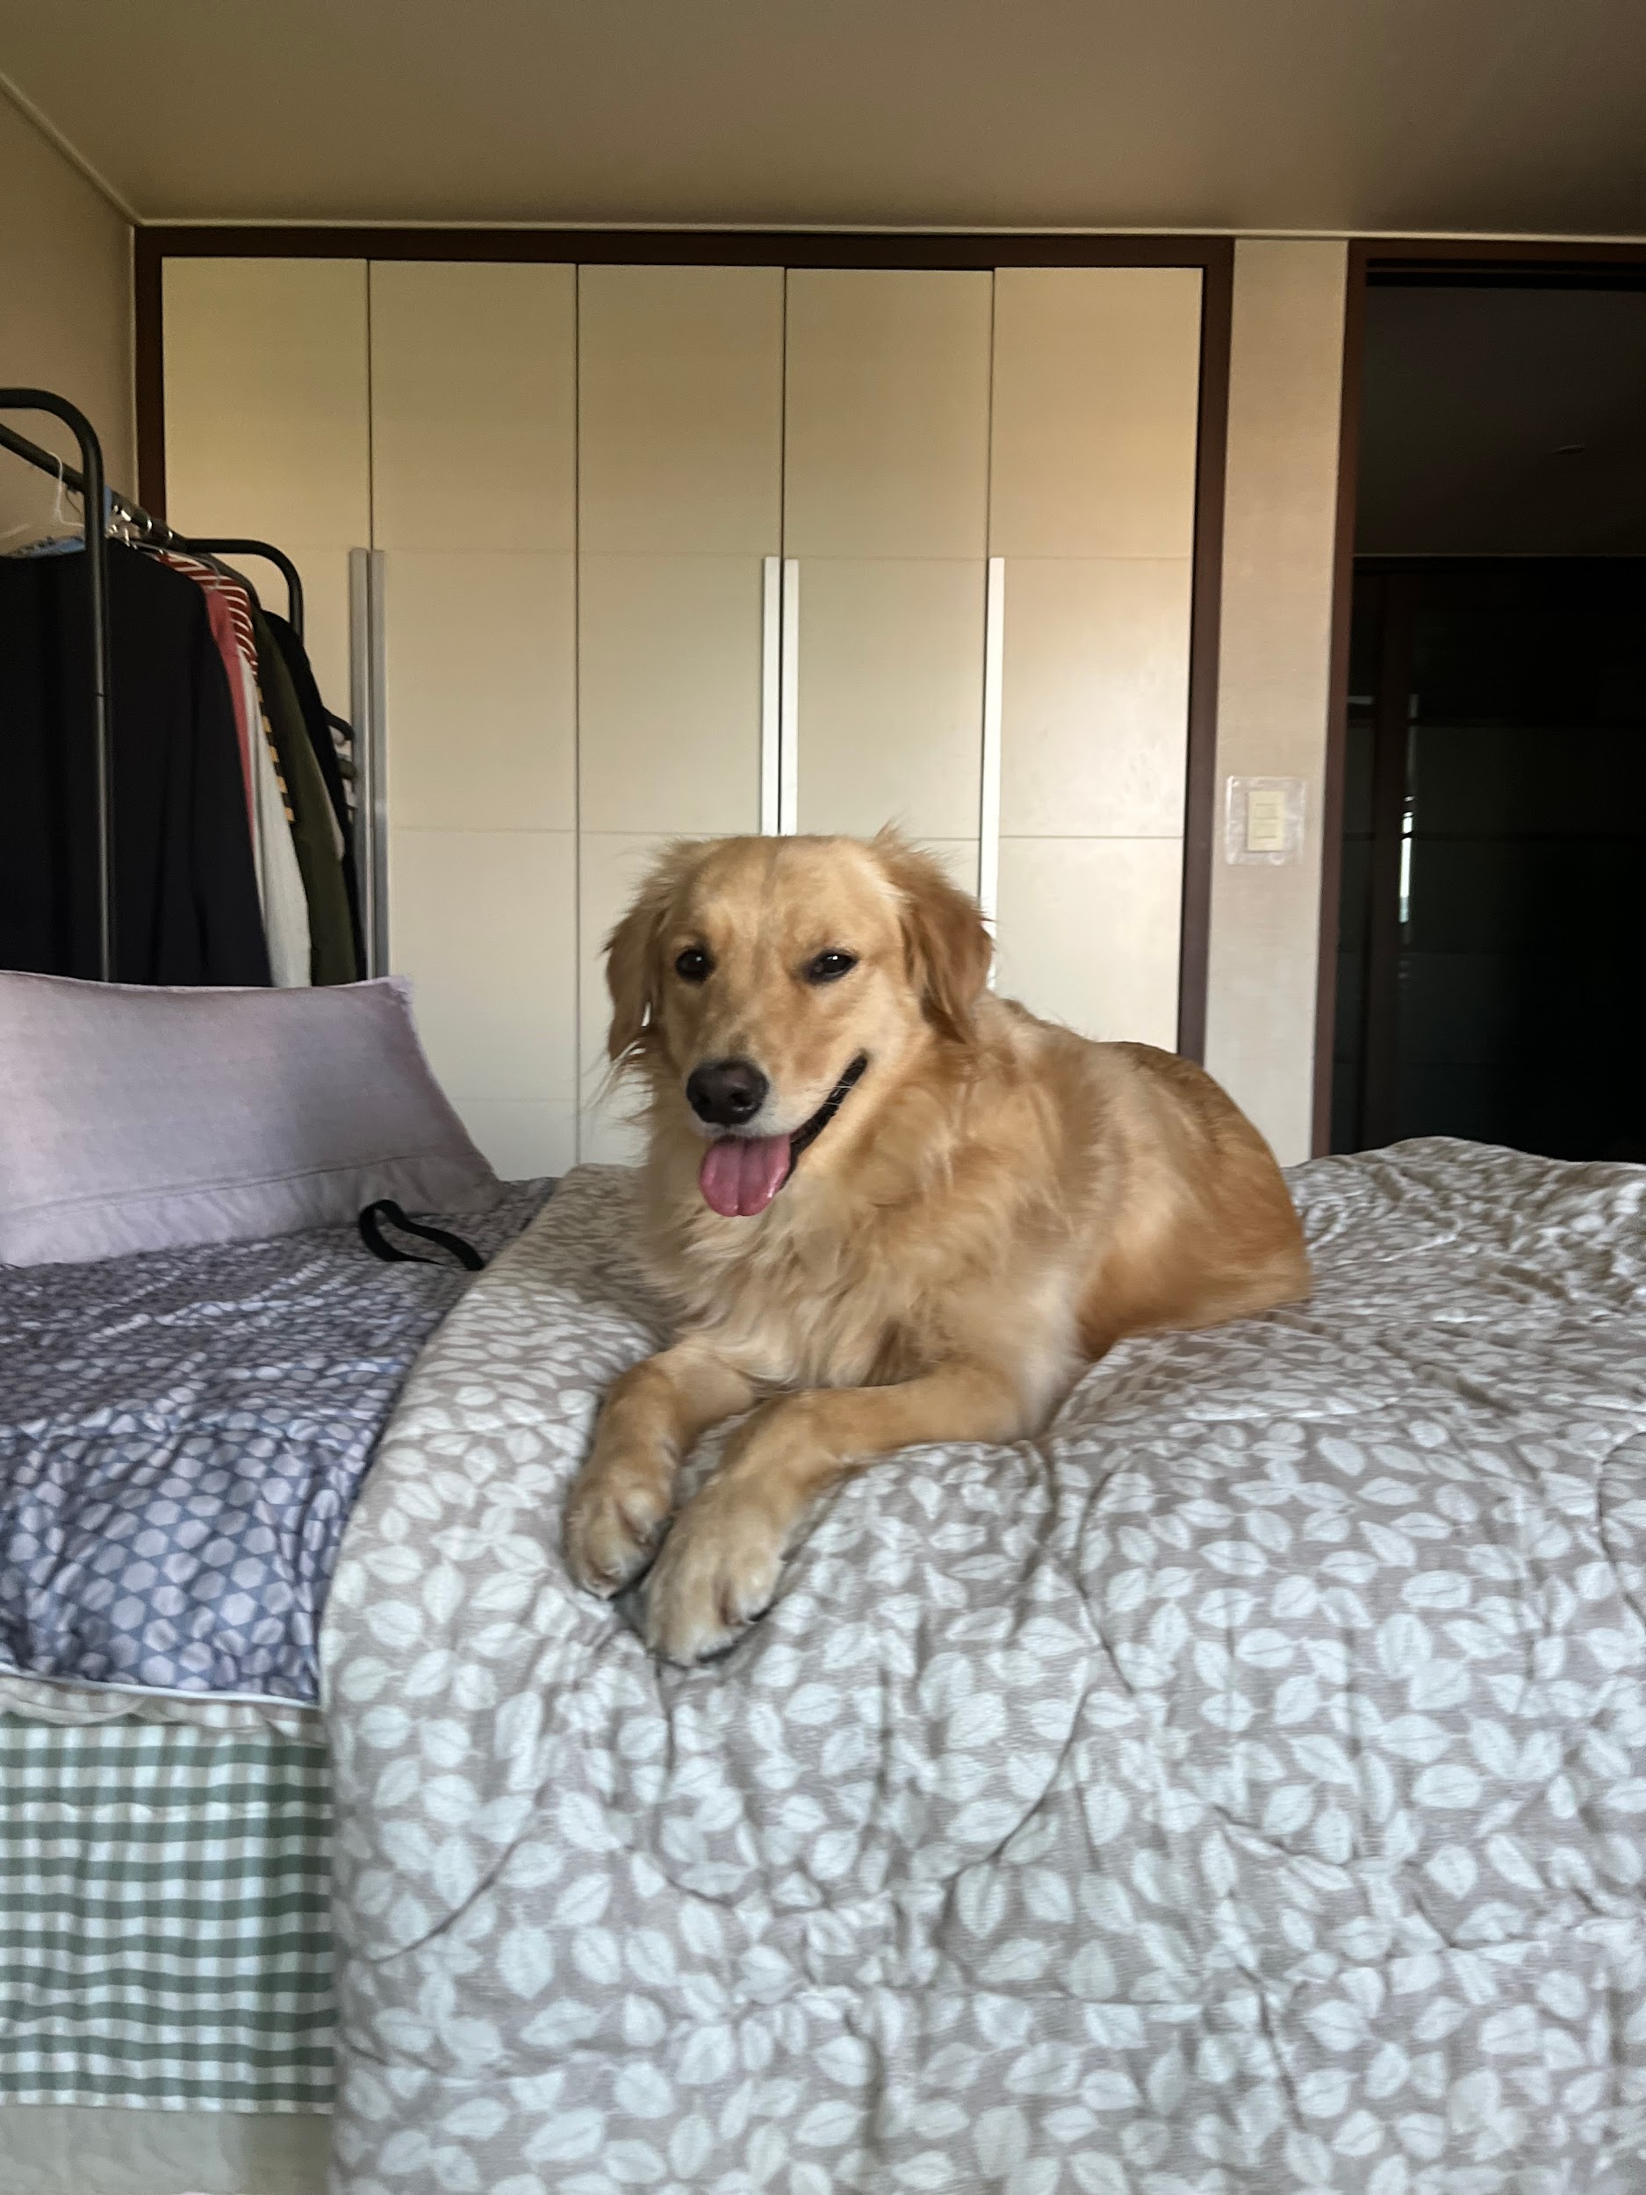
2. sage_classic.jpeg
3. A smiling golden retriever lying on the bed
4. Sage is a 3 year old Golden Retriever. She is one of the laziest dogs. She loves sneaking into the bedroom and hopping onto the neatest bed. She also loves riding in a car with the windows open feeling the wind and air. She enjoys walking, only if you take her for a ride to a big arboretum or park. Walking around the neighborhood is not necessarily her cup of tea.
5. Her favorite food is corn. One day, she stole corn on the cob from the dining table, which was surprising because she is normally gentle and polite. She took the stolen corn to the patio and enjoyed her meal by herself. Unfortunately, the corn turned out to be unripe, so she ended up vomiting it all later.
6. **Photo Gallery**
7. sage_young
8. A young golden retriever is laying down
9. sage_car
10. A happy golden retriever is sitting in the car’s backseat.
11. sage_sleep
12. A golden retriever is sleeping on the couch.
13. sage_pet
14. A man’s hand is petting a golden retriever’s neck.
15. **Likes**
16. Carrot
17. Nap
18. Big park
19. Justin Lee